**Science Day 2015**

What: Fun and exciting science-related activities

Where: Maggie Walker Governor’s School

1000 N. Lombardy Street Richmond, VA 23220

When: Saturday, March 28, 2015, from 9:30 AM— 3:15 PM

Registration forms available on the school’s website.

Contact ashore@gsgis.k12.va.us for more specific information.

Including

• Oobleck!

• DIY Ice Cream!

• Strawberry DNA Extraction!

• And so much more!

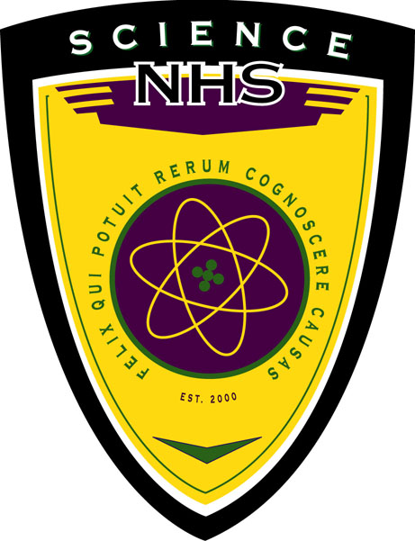

Maggie L. Walker Governor’s School invites you to the second annual Science Day sponsored by the school’s Science National Honor Society.