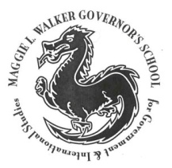

Maggie L. Walker

Governor's School

Science National Honor Society
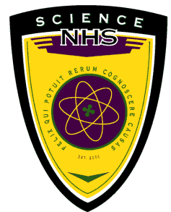

It is our pleasure to invite your 6th and 7th grade students to the eighth annual Governor’s School Science Day. The event will be held on Saturday, March 28th, 2015, at Maggie L. Walker Governor’s School in Richmond City. Sponsored and organized by the school’s Science National Honor Society (SNHS), this event will offer students the opportunity to learn about multiple fields of science through fun hands-on activities and exposure to advanced laboratory techniques.

The day will be filled with a diversity of scientific offerings, or modules, through which students will be exposed to a variety topics. Topics in the past have included some of the following: robotics, pyrotechnics, Emergency Medical Service (EMS) techniques, experiments with a Van de Graaff generator, the physics of egg drops, and the thermodynamics of making ice cream. During the course of each module, students can look forward to brief explanations of the science behind the activity in addition to an exciting demonstration or hands-on portion.

The cost per student for the program is $5. Arrangements can be made should this pose a hardship to any student. Check-in for the occasion will begin as early as 9:00 AM with the program starting at 9:30 AM. The students will remain on the school premises until closing at 3:00 PM. The day will consist of an opening ceremony followed by four different, randomly selected, activities broken up by lunch and finishing with a closing ceremony. Lunch will be provided by SNHS, but transportation will not be.

Registration forms for Science Day are available on the school’s website, http://mlwscience.weebly.com/science-day.html or can be mailed or faxed to your school. The deadline to receive all forms is Monday, March 9th, 2015. In order to complete the registration form, the following information should be included: (1) number of students attending, (2) names of students attending, and (3) contact information for a parent. The information can also be faxed to the school to the attention of the SNHS sponsor, Anna Shore. The fax number is 354-6939 or contact Mrs. Hicks directly at ashore@gsgis.k12.va.us. Please share this information with the middle schools in your area. Spaces are limited and availability is on a first come basis. The school can send in registrants or the parents can register their student independently if they prefer.

Feel free to contact us with questions or concerns that you may have. Thank you for your time, and we look forward to hearing from you soon.

You may direct any immediate questions, comments, or concerns to:
Sponsor: Anna Shore
Mail: 1000 N. Lombardy Street Richmond, VA 23220
Phone: (804) 354 -6800
Email: ashore@gsgis.k12.va.us

